Post-Midsem Week 4 Report - Binomial Option Pricing and Convergence
Project: AI/ML-Augmented Black-Scholes Framework for Option Pricing and Market-Risk Analysis
Plan reference: Post-midsem work plan, Week 4 (work packages 1 and 2)
Primary text: Carol Alexander, Market Risk Analysis Volume I: Quantitative Methods in Finance, section I.5.6
Source: Cox, Ross and Rubinstein (1979), Journal of Financial Economics 7(3)
Submitted by: Sanskar
Contents
1. Objective and scope
2. The CRR lattice and the risk-neutral probability
3. Validation of the implementation
4. Convergence at the specified N
5. The convergence figure
6. The oscillation, and where it comes from
7. Behaviour across moneyness and maturity
8. Conclusions

1. Objective and scope
Weeks 2 and 3 derived the Black-Scholes price and its sensitivities, and verified both internally. Week 4 introduces the first genuinely independent method.
This matters for a specific reason. The binomial model is a discrete-time construction. It shares with Black-Scholes the no-arbitrage principle and the lognormal limit, but none of the continuous-time machinery: no Ito calculus, no partial differential equation, no normal distribution. Agreement between the two is therefore evidence that the Week 2 derivation is correct, not merely that the same formula has been coded twice.
Both work packages were completed.
# | Work package | Deliverable | Status
1 | Implement CRR European call/put and risk-neutral probabilities | binomial.py | Complete
2 | Convergence for N = 10, 25, 50, 100, 250, 500, 1000 | binomial_convergence.png | Complete
The checkpoint question for this week is “Does binomial pricing approach Black-Scholes?” Section 4 answers it directly; section 6 answers the more interesting question of how.
A single driver, postmidsem_week4.py, reproduces every number and figure in this report in about two seconds.

2. The CRR lattice and the risk-neutral probability
Over a step $Δt=T/N$ the underlying moves up by $u$ or down by $d$:
$$u=e^{σ\sqrt{Δt}}, d=\frac{1}{u}=e^{−σ\sqrt{Δt}}$$
Because $ud=1$ the lattice recombines and its centre remains at $S_{0}$, which keeps the number of nodes linear in $N$ rather than exponential.
The risk-neutral probability follows from requiring the asset to grow at the risk-free rate:
$$pu+(1−p)d=e^{(r−q)Δt} ⇒ p=\frac{e^{(r−q)Δt}−d}{u−d}$$
The option value is then the discounted risk-neutral expectation, obtained by backward induction from the terminal payoff.

How the lattice behaves as it is refined
$S=100$, $K=100$, $T=1$, $r=5\%$, $σ=25\%$:
$N$ | $Δt$ | $u$ | $d$ | $p$ | up-move size
1 | 1.0000 | 1.284025 | 0.778801 | 0.539305 | 28.40%
10 | 0.1000 | 1.082266 | 0.923987 | 0.511915 | 8.23%
100 | 0.0100 | 1.025315 | 0.975310 | 0.503752 | 2.53%
1000 | 0.0010 | 1.007937 | 0.992125 | 0.501186 | 0.79%
10000 | 0.0001 | 1.002503 | 0.997503 | 0.500375 | 0.25%
As $N$ grows, $u→1$ and $p→1/2$ from above. The limiting form is
$$p → \frac{1}{2}+\frac{(r−1/2σ^{2})\sqrt{Δt}}{2σ}$$
and the numerator of that correction is exactly the log-drift $μ−1/2σ^{2}$ derived by Ito’s lemma in Week 2. The discrete and continuous constructions agree on the drift correction before any prices are compared.

Validity of $p$
The probability lies strictly in $(0,1)$ only if $d<e^{(r−q)Δt}<u$, that is
$$N>\frac{T(r−q)^{2}}{σ^{2}}$$
Outside that range the “probabilities” are negative and the lattice represents an arbitrage rather than a model. The implementation enforces this rather than assuming it, and raises an error instead of returning a number. Across the full test grid the condition held in every case.

3. Validation of the implementation
Six checks were applied before any convergence claim was made.
Check | Result | Tolerance
Backward induction vs closed form | 4.135e-12 | 1e-09
Put-call parity on the lattice | 3.880e-12 | 1e-09
Risk-neutral probability outside $(0,1)$ | 0 cases | 0
$|$binomial$(N=2000)−$ Black-Scholes$|$ | 3.460e-03 | 5e-02
American put $≥$ European put | 0 violations | 1e-12
American call $=$ European call, no dividend | 0.000e+00 | 1e-09
Three of these deserve comment.
Two independent routes to the same price. Besides backward induction, the module computes the European price in closed form through the binomial distribution,
$$C=Se^{−qT} P[Bin(N,p′)≥a]−Ke^{−rT} P[Bin(N,p)≥a]$$
where $a$ is the smallest number of up-moves finishing in the money. The two are mathematically identical but computationally unrelated, so an off-by-one in the lattice indexing would appear immediately. They agree to 4.1e-12.
Put-call parity holds exactly on the lattice, at any $N$, however coarse. This is a stronger statement than it first appears: it says the binomial model is internally arbitrage-free even when it is inaccurate. Section 4 shows the consequence - the call and put errors against Black-Scholes are identical to every digit.
American pricing was included although the plan requires European only. It costs three additional lines, the early-exercise premium becomes the object of interest later in the project, and it provides two further checks: an American put must never be worth less than a European one, and an American call on a non-dividend-paying asset must be worth exactly the same. Both held exactly.

4. Convergence at the specified N
$S=K=100$, $T=1$, $r=5\%$, $σ=25\%$. Analytical Black-Scholes call price: 12.3359989304.
$N$ | Binomial | $E_{N}$ | $|E_{N}|$ | $N|E_{N}|$
10 | 12.0922535495 | -2.44e-01 | 2.44e-01 | 2.4375
25 | 12.4267079210 | +9.07e-02 | 9.07e-02 | 2.2677
50 | 12.2866845549 | -4.93e-02 | 4.93e-02 | 2.4657
100 | 12.3113097169 | -2.47e-02 | 2.47e-02 | 2.4689
250 | 12.3261157058 | -9.88e-03 | 9.88e-03 | 2.4708
500 | 12.3310560739 | -4.94e-03 | 4.94e-03 | 2.4714
1000 | 12.3335271922 | -2.47e-03 | 2.47e-03 | 2.4717
The answer to the checkpoint question is yes. The absolute error falls from 0.2437 at $N=10$ to 0.0024717 at $N=1000$ - a reduction by a factor of 98.6 for a hundredfold increase in steps, which is the signature of first-order convergence.
The $N|E_{N}|$ column makes this precise. If $E_{N}=O(1/N)$, that product tends to a constant, and it does: 2.4717 at $N=1000$.
Two features of the table are worth noticing before section 6.
The $N=25$ row has the opposite sign to every other row, and its $N|E_{N}|$ settles on a different constant, 2.2677 rather than 2.47.
The put errors are identical to the call errors to every digit shown (put price at $N=1000$: 7.4564696423 against an analytical 7.4589413804, error -2.47e-03). That is put-call parity holding exactly on the lattice, as section 3 established.

5. The convergence figure
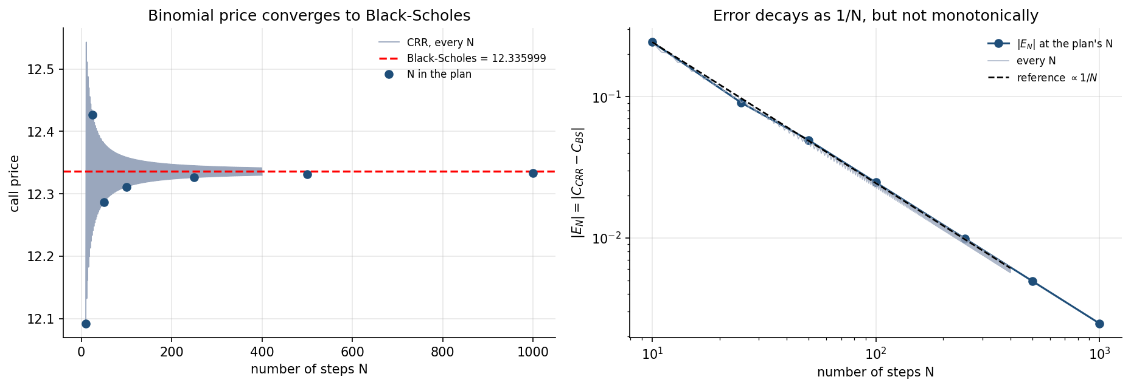
Figure 1. Left: the binomial price against $N$, with the analytical price marked and the seven values specified in the plan highlighted. Right: absolute error on logarithmic axes against a $1/N$ reference line.
The left panel shows the price approaching the Black-Scholes value while visibly alternating about it. The right panel shows that the envelope follows $1/N$ closely, but the individual points scatter into what appears to be two distinct sequences.
That appearance is not noise. Section 6 identifies it exactly.

6. The oscillation, and where it comes from
The error was computed for every integer $N$ from 10 to 400, rather than only the seven values in the plan.

The convergence order
Subsequence | Fitted order | Theory
All $N$ | -0.9999 | -1
Even $N$ only | -0.9981 | -1
Odd $N$ only | -1.0014 | -1
Averaging $N$ and $N+1$ | -0.8743 | -

The decisive statistic
Quantity | Value
Even $N$ producing a negative error | 100.0%
Odd $N$ producing a positive error | 100.0%
Mean $N|E_{N}|$, even $N$ | 2.4690
Mean $N|E_{N}|$, odd $N$ | 2.2605
Across all 391 values of $N$ there is not one exception in either direction. The binomial price sits below Black-Scholes for every even $N$ and above it for every odd $N$, and each branch obeys its own $1/N$ law with its own constant.
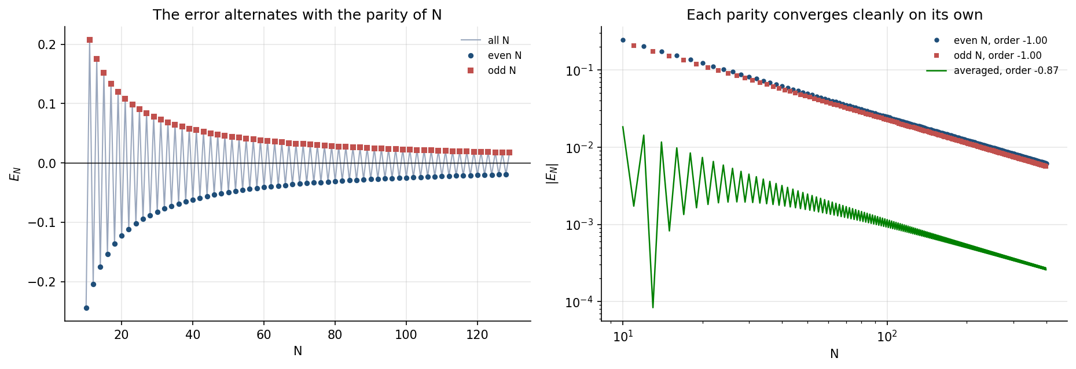
Figure 2. Left: the signed error for $N=10$ to 130, with even and odd $N$ marked separately - the two interleave perfectly either side of zero. Right: each parity on logarithmic axes, each a clean straight line, together with the averaged sequence.

Why this happens
The terminal nodes sit at
$$S_{T}(j)=S\text{exp}\left[(2j−N)σ\sqrt{Δt}\right], j=0,…,N$$
For even $N$ the exponent is zero at $j=N/2$, so a node falls exactly on $S$. For odd $N$ no such $j$ exists and the nodes straddle $S$.
For an at-the-money option, $S$ is precisely where the payoff kink lies. The lattice therefore resolves the kink one way for even $N$ and the other way for odd $N$, and the discretisation error picks up a consistent sign from that geometry.
This is a property of where the nodes land, not a defect in the method. Each parity converges cleanly at first order; only the interleaved sequence looks ragged.

The practical consequence
Averaging consecutive $N$ damps the oscillation:
Quantity | Value
Maximum $|$error$|$, raw | 0.2437
Maximum $|$error$|$, averaging $N$ and $N+1$ | 0.0183
A factor of 13 improvement at the cost of one extra lattice. This is why production implementations commonly price at $N$ and $N+1$ and take the mean, and it is the simplest example in this project of a numerical fix that comes from understanding the error rather than from brute force.

7. Behaviour across moneyness and maturity
The agreement was tested away from the money and at other maturities, at $N=1000$.
Calls at $T=1$, $K=100$:
$S$ | $m=\text{ln}(S/K)$ | Binomial | Black-Scholes | Absolute error | Relative error
80 | -0.2231 | 3.140440 | 3.141523 | 1.08e-03 | 3.45e-04
90 | -0.1054 | 6.871217 | 6.869814 | 1.40e-03 | 2.04e-04
100 | 0.0000 | 12.333527 | 12.335999 | 2.47e-03 | 2.00e-04
110 | 0.0953 | 19.303322 | 19.305092 | 1.77e-03 | 9.17e-05
120 | 0.1823 | 27.407835 | 27.406343 | 1.49e-03 | 5.45e-05
Across the full grid of five spot levels, three maturities and both option types:
Quantity | Value
Maximum absolute error | 3.459e-03
Maximum relative error | 1.045e-03
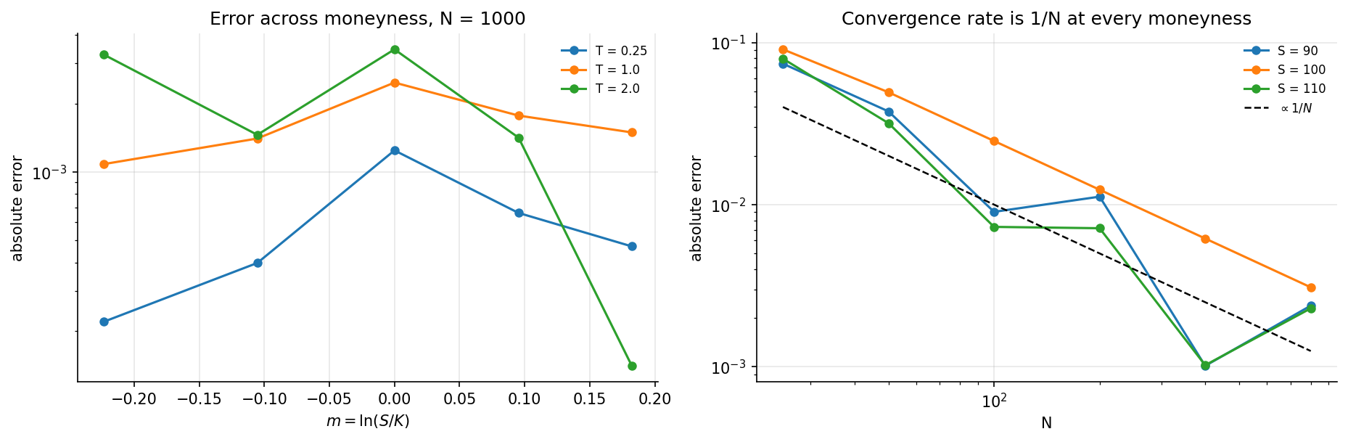
Figure 3. Left: absolute error across log moneyness at three maturities. Right: convergence rate at three moneyness levels, each tracking $1/N$.
The absolute error is largest at the money, which is consistent with section 6: that is where the payoff kink sits and where the lattice geometry matters most. The relative error behaves oppositely, falling as the option moves into the money simply because the price itself grows.
The convergence rate is $1/N$ at every moneyness tested. The oscillation is strongest at the money and weakens away from it, again consistent with the kink explanation.

8. Conclusions
- Both Week 4 work packages were completed. The CRR lattice is implemented with risk-neutral probabilities and validated by six independent checks.
- The binomial price converges to Black-Scholes at first order. The fitted convergence order is -0.9999 against a theoretical -1, and the absolute error falls by a factor of 98.6 between $N=10$ and $N=1000$.
- The implementation is verified by two mathematically identical but computationally unrelated routes - backward induction and the closed-form binomial expression - agreeing to 4.1e-12.
- Put-call parity holds exactly on the lattice at any $N$. The binomial model is internally arbitrage-free even when coarse, and consequently the call and put errors against Black-Scholes are identical.
- The convergence is not monotone, and the pattern is entirely systematic. Across 391 values of $N$, the binomial price lies below Black-Scholes for 100% of even $N$ and above it for 100% of odd $N$. The cause is the position of the terminal nodes relative to the strike: an even $N$ places a node exactly at $S$, an odd $N$ straddles it, and for an at-the-money option that is where the payoff kink lies.
- Averaging consecutive $N$ reduces the maximum error from 0.2437 to 0.0183, a factor of 13 for one additional lattice.
- Agreement holds across moneyness and maturity, with a maximum absolute error of 3.46e-03 at $N=1000$ over the full test grid.
The wider significance. Black-Scholes was derived in Week 2 from Ito’s lemma, delta hedging and a no-arbitrage argument in continuous time. The binomial model reaches the same prices from a discrete lattice with none of that apparatus. Their agreement to three decimal places at $N=1000$, approaching at a measured first-order rate, is independent evidence that the Week 2 derivation is correct - not merely that it was transcribed correctly into code.
Position going into Week 5. Two of the three pricing methods now agree. Week 5 adds Monte Carlo, which introduces a different kind of error: statistical rather than discretisation, and therefore quantified by a confidence interval rather than a convergence order. The three-method comparison then follows.

